Phase 1: Before you write a single word

You can't write a native ad that feels real if you don't know who you're talking to.
Most ads fail before the first word is written — not because the copy is bad, but because the writer is guessing. They know the product. They don't know the person.
This module fixes that.
By the end, you'll have a complete diagnosis of your audience — what they've tried, what they believe, what they feel, and the exact words running through their head. Takes 30-60 minutes. Skip it and your ads will sound like ads.

Section 1: The 6 Diagnosis Questions

Answer these before you write anything.

1. Who is this for exactly?
Not demographics. Psychographics.
What does their day look like? What moment are they in… starting to notice the problem, deep in frustration, or ready to give up? What are they doing when they see your ad?

2. What have they already tried?
List everything. Diets, supplements, apps, doctors, advice from friends, things they bought from other ads.
This matters because they're not a blank slate. They're skeptical. If your ad sounds like the same stuff they've tried, they scroll.

3. What are they emotionally tired of?
Not tired of the problem - tired of what specifically?
Being dismissed by doctors? Advice from people who don't get it? Trying things that work for everyone else but not them? Feeling like a failure?
This is different from the problem itself. This is the emotional exhaustion that comes from living with the problem and trying to solve it.

4. What do they believe is the cause?
They have a theory. It might be wrong, but they believe it.
"My metabolism slowed down."
"It's genetic."
"I don't have willpower."
"It's stress."
These beliefs matter because they shape how they see solutions. If they believe the cause is genetics, they'll be skeptical of anything that claims to help - because how can you fight genetics?
Your ad either works with this belief or shifts it.

5. What do they believe is NOT the cause?
This is where the opportunity lives.
If they think it's willpower but it's actually hormonal, you've found your angle. The belief they're missing is your opening.
Your ad can introduce a new way of seeing the problem. That's the belief shift.

6. What are they afraid to try next?
More money wasted? More hope crushed? Looking stupid for believing another ad?
This fear stops them from clicking even when they believe you. Note it down, so you can address it later.

Example: Women's Hormone Supplement Brand

Question | Answer
Who exactly? | Women 45-60, peri/post-menopausal. Scrolling at night because they can't sleep. Gained 15-20 lbs in 2 years despite eating the same. Feel betrayed by their body.
Already tried? | Calorie counting, keto, intermittent fasting, walking more, their doctor ("just aging"), maybe endocrinologist, Amazon supplements that did nothing.
Emotionally tired of? | Being dismissed. Doing everything right and failing. Husband not understanding. Doctors treating them like a number.
Believe is the cause? | "Metabolism is broken." "It's menopause." "Hormones are out of whack but doctors won't help."
Believe is NOT the cause? | Don't connect gut health or cortisol to weight. Think it's purely ovarian hormones.
Afraid to try next? | Wasting another $50-100. Getting hopes up again. Feeling stupid for believing another ad.

Section 2: Male vs Female Psychology
Same product, different psychology.

Write to the wrong lens and they scroll without knowing why.

 | Women | Men
The problem means... | Identity + relationships.  Not "I want to lose weight" but "I got tagged in a photo and didn't recognize myself. I avoid mirrors. I canceled plans because I didn't want to be seen."  "I don't recognize myself."  "How do I show up for my kids?"  "Does my husband still see me?" | Status + capability.  Health issues aren't about health. They're about being sidelined. Not being able to provide, protect, lead.  "I'm losing my edge."  "Younger guys are passing me."  "I let this happen."
Skepticism trigger | "Is this person real or is this marketing?"  Claims too big, timelines too fast, language too polished. | "Is this thing legit?"  Does the mechanism make sense? What's the catch? Sounds too easy.
What earns trust | Specificity that feels like lived experience. Acknowledging the hard parts. Proof from women who sound like them. | Authority and credentials first. Specific numbers and results. Mechanism that logically tracks.
Proof format | Stories > statistics. She's looking for the woman who sounds like her. | Results > relatability. Numbers, timeframes, specifics. "Lost 30 lbs in 12 weeks" > emotional journey.
What passes the filter | Details too specific to be made up. The narrator admitting doubt or struggle. | Credentials upfront. Logic that tracks. Acknowledging who it's NOT for.

The overlap:
Both need specificity. Both need believable proof. Both need the real pain, not the surface version.
Women see the problem through relationships and identity. Men see it through status and capability. Write to the wrong lens and they'll just leave.

Section 3: Awareness Levels

Your ad must match where the reader is right now. Wrong level = they scroll.
When writing copy for native ads, we target 3 awareness levels:
- Problem Aware
They know something's wrong. They feel it daily. But they don't fully understand why or what to do about it.
- Not searching for solutions yet — still trying to understand the problem
- Looking for someone who gets what they're going through
- Skeptical of products because they don't trust their own diagnosis yet
When they see your ad, they're not thinking about products. They're thinking about their situation. They're wondering if anyone else feels this way. They're looking for someone who understands.

- Solution Aware
They know solutions exist. They've tried some. They've been disappointed.
- Comparing options, reading reviews, looking for proof
- Don't need education on the problem — they live with it
When they see your ad, they're evaluating. They're asking, "Why should I believe this one? What makes this different? Is this just another thing that won't work?"

- Product Aware
They know your product specifically. Seen your ads. Maybe visited your site. Maybe abandoned cart.
- Don't need convincing on problem or solution
- Need the final push — proof, risk reversal, urgency
- Looking for a reason to act now
When they see your ad, they're looking for a reason to act now. Social proof. Risk reversal. A guarantee. A discount. Something that tips them over the edge.

Why only these three?
Unaware audiences take too much effort to convert — you're paying to educate people who don't even know they have a problem.
Most aware audiences don't need ads — they've already bought. Repeat purchases happen through email, SMS, and retention flows.
Native ads work best in the middle: Problem Aware, Solution Aware, Product Aware.

Section 4: Believability Quadrant

Before you write, know how hard the sell is.
Two questions determine this:
- Do they believe in this type of solution?
- Does your mechanism align with what they already believe?

 | Believes in solution category | Doesn't believe in solution category
Mechanism aligns with their beliefs | Easy Sell. They get it. Focus on why yours is better.  Example: Protein powder for gym-goers.  natural solutions because they are better than pharmaceuticals (at least what they believe in) | Education Sell. They've never heard of this. But once explained, it clicks.  Example: Mouth tape for people with sleep issues.
Mechanism conflicts with their beliefs | Reframe Sell. They want to solve it — but believe in a different solution. Villain the old belief first.  Example: Oil cleanser for people who think oil causes acne.  Carbs-based diet for people who think carbs cause weight gain. | Hard Sell. Multiple belief layers to break. Heavy proof required.  Example: Migraine supplement for people who think migraines are random and supplements are useless.

Which quadrant are you in?
Ask yourself:
- Has my audience bought this type of product before? (Yes = believes in category)
- Will my explanation of how it works make them nod or raise an eyebrow? (Nod = aligns. Eyebrow = conflicts.)
Know your quadrant. Identify which beliefs you're working with and which you need to shift. This shapes your entire copy strategy.

Section 5: Dominant emotion
Surface pain is what they'll say out loud. Real pain is what they think about at 2am.
Your ad needs to speak to the real pain.
Surface vs Real:
Surface pain | Real pain
"I want to lose weight." | "I got tagged in a photo and didn't recognize myself. I avoid mirrors. I canceled plans because I didn't want to be seen."
"I'm tired all the time." | "I have nothing left for my kids by 6pm. I'm surviving, not living. I snap at people I love."
"My skin is breaking out." | "I don't want my husband to see me without makeup. I avoid eye contact with people."
"I can't sleep." | "I dread going to bed. I lie there for hours with my thoughts racing. I'm exhausted but wired."

The Emotional Map:
Every reader exists somewhere on this spectrum. Your ad meets them where they are.
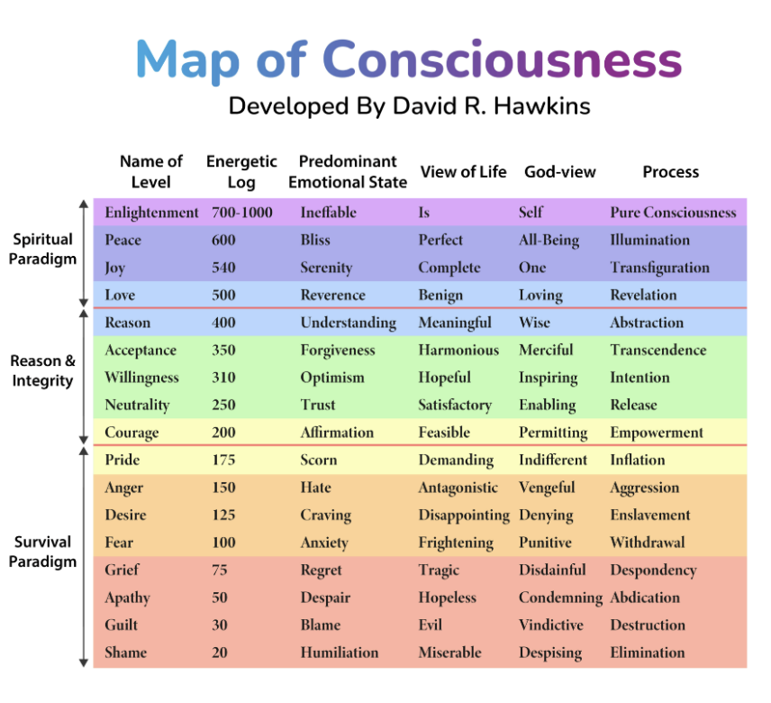

Level | State | What it sounds like | Your ad needs to...
Low | Shame / Hopeless | “I did this to myself. I have no one to blame. I can't even look at myself anymore. Why am I so weak?” | Offer safety. No judgment. Permission to try again.
 | Grief / Defeated | "I used to be able to do this. What happened to me? I've tried everything and I'm still here. Maybe this is just who I am now." | Acknowledge the exhaustion. Make trying feel low-risk.
 | Fear / Anxious | "What if I spend money again and it doesn't work? What if I'm the only one it doesn't work for? What if my body is actually broken?" | Address risk directly. Guarantees. Proof from skeptics.
 | Anger / Frustrated | "My doctor brushed me off. My husband doesn't get it. Everyone has advice but no one actually understands. I'm sick of being told to try harder." | Validate the anger. Villain the system that failed them.
Mid | Skeptical / Guarded | "This is probably another scam. I've seen these ads before. They all say the same thing. Why would this one be different?" | Heavy proof. Acknowledge the skepticism out loud.
 | Neutral / Open | "Okay, I'm listening. I don't fully believe it yet but I'm not closing the door. Show me how it works." | Mechanism explanation. Logical case + social proof.
Higher | Hopeful / Ready | "Something has to work. I'm ready to try again. I just need to find the right one." | Clear offer. Reason to act now. Risk reversal.
Most of your buyers live in the lower half. Your ad moves them up — one level at a time.

How to find the dominant emotion:
- What relationships does it affect? A problem that affects how they see themselves is one thing. A problem that affects their marriage, their kids, their friendships — that's deeper.
- What situations make it spike? When does it go from background noise to unbearable? Getting dressed for an event. Being tagged in a photo. A comment from their partner. These situations are where the emotion is most raw. When your copy describes these moments, the reader feels like you've been watching their life.
- What do they feel underneath? Shame, loss of control, fear, grief, invisibility — which one?
Name the real pain. Match the emotional level. That's what makes them stop scrolling.

Section 6: Extracting Audience Language
You now understand who you're writing for, what they've tried, what they believe, and what they feel.
The last piece: how do they actually talk about it?
This matters because if your copy sounds like marketing, they'll tune out. If it sounds like them… like the words they use in their own head… they'll lean in.

Where to find it:

Source | Why it works
Amazon reviews (competitor products) | People write detailed, emotional reviews when something worked or didn't. Raw and unfiltered.
Reddit threads (relevant subreddits) | Anonymous = honest. They say things here they won't say anywhere else.
Facebook comments on competitor ads | Real objections, real frustrations, real questions - all in one place.
Facebook groups about the problem | People venting to others who understand. Gold for language patterns.
What to look for:
- Phrases that repeat across multiple people (that's signal)
- Exact words they use to describe the problem (not your words — theirs)
- How they describe failed solutions ("I tried X and it made me feel...")
- Emotions underneath the complaints (angry? defeated? embarrassed? hopeful?)

Example phrases (women's weight loss audience):
- "I'm doing everything right and the scale won't budge"
- "I don't even recognize myself anymore"
- "My doctor just told me to eat less and move more"
- "Nothing works the way it used to"
- "I feel like a stranger in my own body"
- "I'm so tired of trying"

Section 7: Checklist
By this point, you should have:
☐ 6 diagnosis questions answered
☐ Male or female psychology identified
☐ Awareness level chosen
☐ Believability quadrant identified (Easy, Education, Reframe, or Hard Sell)
☐ Dominant emotion named (not surface pain, the real pain)
☐ 15-20 audience language phrases collected
If any box is empty, go back. Everything you write depends on this.

That's Phase 1. You now have a framework for understanding any audience - not as a demographic, but as a real person with beliefs, emotions, and language patterns.
This is the foundation. Every ad you write builds on what you uncovered here.
Next, we go into story elements that make native ads work - structure, narrator, discovery, and belief shift and how that changes everything about how you write.

